SYSTEMS DESIGN DOCUMENT

GROUP MEMBERS.

1.Tumusiime Arnold

2.Muyanja Rodney

3.Tusiime Allan

4.Shyaka Stephen

* ***DATA PIPELINE DIAGRAM.***

Model Deployment

Data Wrangling

Data Modelling

Data Loading

* ***DESCRIPTION OF KEY COMPONENTS IN THE DATA PIPELINE DIAGRAM.***
* Data Loading.

This involves loading of data into the pipeline in a particular format from the data source. Our dataset is collected from Xindi.Africa and is in CSV format.

This involves the use of a python library known as pandas which is imported as pd for usability purposes in the code. This library is used to load the dataset into the pipeline by running a method called pd.read_csv(url). This particular library is preferred because of its immense ability to load various datasets in various formats.

* Data Wrangling.

This involves cleaning of data before use. For our particular dataset we carried out label encoding so as to assign digits to strings, feature scaling, and also dropped columns with missing values and other irrelevant columns.

This also involves the use of the pandas python library. Here various methods are used such as the pd.get_dummies for label encoding, pd.concat for combining dataframes, pd.drop for dropping columns. This particular library is preferred because of it contains all these various methods to clean datasets in ones preferred way.

* Data Visualization.

This involves visualizing various features within the dataset so as to perform analysis in the dataset features. This also helps in performing feature correlation so as to know what features to be dropped.

This component involves the use of the matplotlib and seaborn python libraries. These libraries are used to create various visual formats that are based upon to create the analysis on the dataset.

* Data Modelling.

This involves creating models and training them to correlate the data with the outcomes. Various models are used but the one with the best accuracy score is chosen to be deployed. These Models include

* LogisticRegression model.
* SVC model.
* KNeighborsClassifier model.
* DecisionTreeClassifier model.

This component involves the use of the sklearn, numpy, and pandas python libraries. The numpy library is preferred because it is able to manipulate various mathematical functions, and the sklearn library is preferred because it is able to create models using their respective methods.

* Model Deployment.

This involves deployment of the models with the highest score after using the train data. The test data is the used by the selected models. This component involves the use of the sklearn, numpy, and pandas python libraries. The numpy library is preferred because it is able to manipulate various mathematical functions, and the sklearn library is preferred because it is able to create models using their respective methods.

* ***Visualization Components.***

To give more insights to the fraude_detection dataset, we made use of 3 bar graphs and two scatter plots as shown below;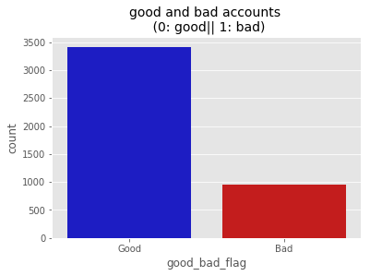

The above bar graph is to compare the number of good accounts(without fraud) and the bad ones (with fraud). We made make use of a bar graph since it easily shows comparison between the components of the good and bad accounts.

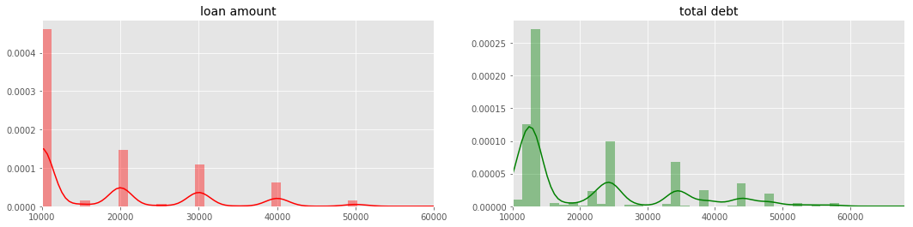

The second figure shows two graphs i.e loan amount and total debt.

The ‘loan amount’ bar graph describes the customers’ tendencies and what kinds of loans they tend to opt for when they borrow money.

The ‘total debt’ bar graph then shows the debts that are owed to the company along with the interests that come along.

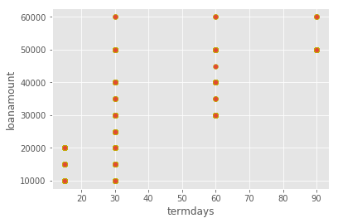

The third figure is the first scatter plot that we use to show the company’s tendency to give ‘termdays’ ( time frame with in which the debt should be paid along with interest) depending on how much money a customer borrows, we used the scatter plot because we assumed continuity in the ‘termdays’ given out.

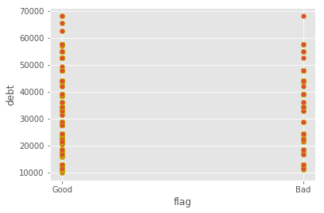

The fourth figure is also a scatter plot ,which we used to show which kind of accounts are usually fraud i.e bad. Depending on how much is owed, the above plot shows us that most fraud accounts are those that owe 20000 to 45000. And the rest are hardly fraud. With this we can move on to the prediction and detection phase. This scatter plot also helps us have a target on what kind of accounts to watch out for and also may be advise the company to regulate such accounts.